AWS SQS, MQ & AWS Secrets Manager
AWS Level 1 Learning Notes
Amazon SQS, Amazon MQ & AWS Secrets Manager

Introduction
Modern cloud applications need to:
- Communicate with each other
- Handle millions of user requests
- Secure passwords and API keys
AWS provides several services to solve these challenges. In this document, we will learn three important AWS services:
- Amazon SQS (Simple Queue Service)
- Amazon MQ
- AWS Secrets Manager
Each service solves a different problem in cloud applications.

1. Amazon SQS (Simple Queue Service)
What is Amazon SQS?
Amazon SQS is a fully managed message queue service that allows applications to communicate with each other by storing messages in a queue until another application is ready to process them.
Simple Definition
Amazon SQS is a service that stores messages temporarily so applications can process them later.

Real-World Analogy
Imagine a restaurant.
Customers place food orders.
The chef cannot cook every order immediately.
The waiter writes each order on a slip and places it in an order queue.
The chef picks one order at a time and prepares it.
The order queue works exactly like Amazon SQS.
Customer

↓

Order Queue (SQS)

↓

Chef

Why AWS Created Amazon SQS
Without a queue:
Customer

↓

Application

↓

Database
If millions of users send requests at the same time, the application or database may become overloaded and crash.
With Amazon SQS:
Customer

↓

Application

↓

Amazon SQS Queue

↓

Backend Server

↓

Database
Requests wait safely inside the queue until the backend server is ready.
This improves reliability and prevents application failures.

How Amazon SQS Works
Step 1:
Customer performs an action (e.g., places an order).
↓
Step 2:
Application creates a message.
↓
Step 3:
The message is stored in Amazon SQS.
↓
Step 4:
A backend application reads the message.
↓
Step 5:
The backend processes the request.
↓
Step 6:
The processed message is deleted from the queue.

What is a Message?
A message is simply information.
Example:
Customer Name : John

Product : Laptop

Amount : ₹50,000
This information becomes one message inside Amazon SQS.

Types of Amazon SQS Queues
1. Standard Queue
- Very fast
- High throughput
- Message order is not guaranteed
- Duplicate messages are possible
Example:
Sent:
1
2
3
4
Received:
2
1
4
3
Best for:
- Email notifications
- Image processing
- Log processing

2. FIFO Queue
FIFO stands for First In, First Out.
- Messages are processed in order
- No duplicate messages
Example:
Sent:
1
2
3
4
Received:
1
2
3
4
Best for:
- Banking
- Payments
- Order processing
- Financial systems

Features
- Fully managed
- Highly scalable
- Durable message storage
- Secure with IAM
- Supports encryption
- Reliable
- No server management

Advantages
- Easy to use
- Handles traffic spikes
- Prevents application crashes
- Highly scalable
- Cost-effective
- Reliable

Disadvantages
- Not suitable for real-time communication
- Small delay before processing
- FIFO queues have lower throughput than Standard queues

Real-World Use Cases
- E-commerce order processing
- Email notifications
- Image resizing
- Video processing
- Banking transactions

Interview Questions
Q1. What is Amazon SQS?
A fully managed message queue service.

Q2. Why do we use Amazon SQS?
To decouple applications and handle sudden traffic spikes.

Q3. What are the two types of SQS queues?
- Standard Queue
- FIFO Queue

Q4. What is FIFO?
First In, First Out.

Q5. Who deletes messages from SQS?
The consumer application after processing.

2-Minute Presentation
"Amazon SQS is a fully managed message queue service provided by AWS. It enables applications to communicate asynchronously by storing messages in a queue until they are processed. We can compare it to the token system in a bank or the order queue in a restaurant. Instead of processing every request immediately, applications place requests into a queue, allowing backend servers to process them one by one. This prevents application failures during heavy traffic. Amazon SQS provides Standard Queues for high-speed processing and FIFO Queues for guaranteed message ordering. It is widely used in e-commerce, banking, notifications, and image processing systems."

2. Amazon MQ
What is Amazon MQ?
Amazon MQ is a fully managed message broker service that allows applications to exchange messages using standard messaging protocols.
Simple Definition
Amazon MQ is a managed messaging server for applications that already use traditional messaging systems.

Real-World Analogy
Imagine your company uses an old office intercom system.
When moving to a new building, instead of replacing the entire system, someone manages the same intercom system for you.
You continue using it without changing how it works.
Amazon MQ works the same way.
AWS manages the messaging server while applications continue communicating normally.

Why AWS Created Amazon MQ
Many organizations already used messaging software such as:
- ActiveMQ
- RabbitMQ
When moving to AWS, they did not want to rewrite their applications.
Amazon MQ helps migrate these applications to AWS with minimal changes.

How Amazon MQ Works
Application A

↓

Amazon MQ Broker

↓

Application B
The broker receives messages and delivers them to the appropriate application.
AWS manages the infrastructure.

Amazon SQS vs Amazon MQ
Amazon SQS | Amazon MQ
Message Queue | Message Broker
AWS-native | Supports industry-standard protocols
Simple | More advanced
Cloud-native applications | Legacy enterprise applications

Features
- Fully managed
- High availability
- Supports multiple messaging protocols
- Secure communication
- Easy migration

Advantages
- Easy migration from on-premises systems
- AWS manages infrastructure
- Supports existing enterprise applications
- Reliable messaging

Disadvantages
- More complex than SQS
- Higher cost
- Requires knowledge of messaging brokers

Real-World Use Cases
- Banking
- Insurance
- Manufacturing
- Airline reservation systems
- Legacy enterprise applications

Interview Questions
Q1. What is Amazon MQ?
A fully managed message broker.

Q2. Why use Amazon MQ instead of SQS?
When existing applications already use messaging protocols like JMS or AMQP.

Q3. Does Amazon MQ replace Amazon SQS?
No.
Both solve different business problems.

2-Minute Presentation
"Amazon MQ is a fully managed message broker service provided by AWS. It helps organizations migrate existing messaging applications to AWS without changing their application code. Unlike Amazon SQS, which is an AWS-native queue service, Amazon MQ supports industry-standard messaging protocols such as JMS and AMQP. AWS manages the messaging infrastructure, allowing organizations to focus on their applications instead of server maintenance. It is commonly used in banking, insurance, manufacturing, and enterprise applications."

3. AWS Secrets Manager
What is AWS Secrets Manager?
AWS Secrets Manager is a service that securely stores and manages sensitive information such as passwords, API keys, and database credentials.
Simple Definition
AWS Secrets Manager is a secure digital locker for application secrets.

Real-World Analogy
Imagine keeping your house keys.
Would you leave them outside your door?
No.
You store them inside a secure locker.
Applications also need secure storage for passwords and API keys.
AWS Secrets Manager acts as that secure locker.

Why AWS Created Secrets Manager
Previously, developers often stored passwords:
- Inside application code
- In configuration files
- In source code repositories
This created security risks.
AWS Secrets Manager provides a centralized and secure way to store secrets.

How Secrets Manager Works
Application

↓

Requests Secret

↓

AWS Secrets Manager

↓

Returns Password

↓

Application connects to Database
The password is never hardcoded inside the application.

What is a Secret?
Examples include:
- Database passwords
- API Keys
- OAuth Tokens
- Access Tokens
- Third-party credentials

Features
- Secure storage
- Encryption
- Automatic secret rotation
- IAM access control
- CloudTrail auditing

Advantages
- Improves security
- Eliminates hardcoded passwords
- Supports automatic rotation
- Easy integration with AWS services

Disadvantages
- Additional AWS cost
- Applications must retrieve secrets programmatically

Real-World Use Cases
- Database credentials
- API keys
- Third-party authentication
- OAuth tokens
- Microservices security

Interview Questions
Q1. What is AWS Secrets Manager?
A secure service for storing and managing sensitive information.

Q2. What is a secret?
Sensitive information such as passwords or API keys.

Q3. Why shouldn't passwords be stored in code?
Because they can be exposed and are difficult to manage securely.

Q4. Can Secrets Manager rotate passwords automatically?
Yes, for supported services.

2-Minute Presentation
"AWS Secrets Manager is a secure service that stores and manages sensitive information such as database passwords, API keys, and authentication tokens. Instead of storing credentials inside application code, developers retrieve them securely from Secrets Manager whenever needed. This improves security and simplifies credential management. AWS Secrets Manager also supports encryption, IAM-based access control, auditing through CloudTrail, and automatic secret rotation. It is widely used to protect sensitive information in cloud applications."

Quick Comparison
Service | Purpose | Best Use Case
Amazon SQS | Message Queue | Decoupling applications and handling traffic spikes
Amazon MQ | Message Broker | Migrating legacy messaging applications
AWS Secrets Manager | Secret Storage | Securely storing passwords, API keys, and credentials

Key Takeaways
Remember Amazon SQS When:
- Applications need to communicate asynchronously.
- You want to prevent application overload.
- You need a reliable message queue.

Remember Amazon MQ When:
- Migrating legacy enterprise applications.
- Existing applications use messaging brokers like ActiveMQ or RabbitMQ.
- Standard messaging protocols are required.

Remember AWS Secrets Manager When:
- Storing passwords securely.
- Protecting API keys and database credentials.
- Automatically rotating secrets.

Final Summary
- Amazon SQS helps applications communicate by storing messages in a queue until they are processed.
- Amazon MQ provides a managed messaging broker for existing enterprise applications that use traditional messaging protocols.
- AWS Secrets Manager securely stores passwords, API keys, and other sensitive information while reducing security risks.
Together, these services improve application reliability, communication, and security in AWS cloud environments.

SQS Tasks:
Task 1: Create an Amazon SQS Queue and Send Messages
Objective
In this lab, you will:
- Create an SQS Queue
- Send Messages
- View Messages
- Understand how a Queue stores messages

Architecture
User

↓

Amazon SQS Queue

↓

Messages Stored

Step 1: Login
Open
https://console.aws.amazon.com
Login using your AWS Account.

Step 2: Search for SQS
In the Search Bar
Type
SQS
Click
Simple Queue Service
You will see the SQS Dashboard.

Step 3: Create Queue
Click
Create Queue

You will see two options.
Standard

FIFO
Choose
Standard

Step 4: Queue Name
Enter
StudentQueue
Leave everything else as default.
Click
Create Queue
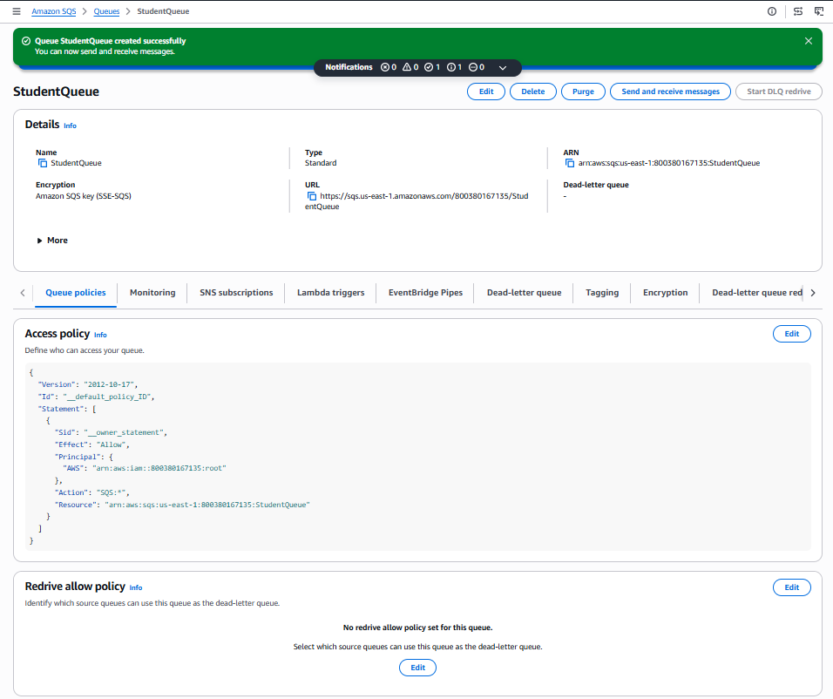
Step 5: Open Queue
Click
StudentQueue
You will see information like
- Queue URL
- ARN
- Monitoring
- Encryption
Don't worry about these yet.

Step 6: Send Message
Click
Send and receive messages
Scroll down.
Inside
Message Body
Type
Student Name: Rahul

Course: AWS

Status: Registered
Click
Send Message
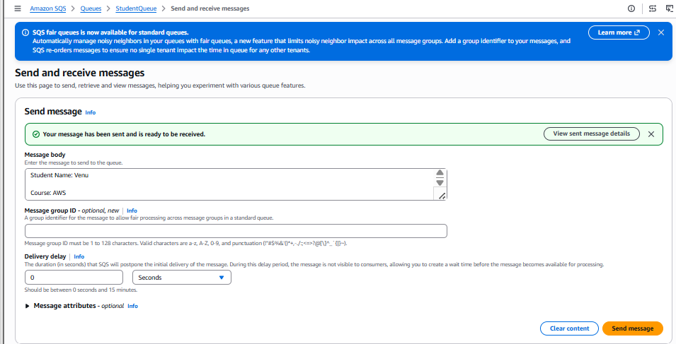

AWS displays
Message sent successfully
Your message is now waiting inside the queue.

Step 7: Send More Messages
Send another message
Student Name: Priya

Course: DevOps

Status: Registered
Send one more
Student Name: John

Course: Cloud

Status: Pending
Now your queue contains
3 Messages
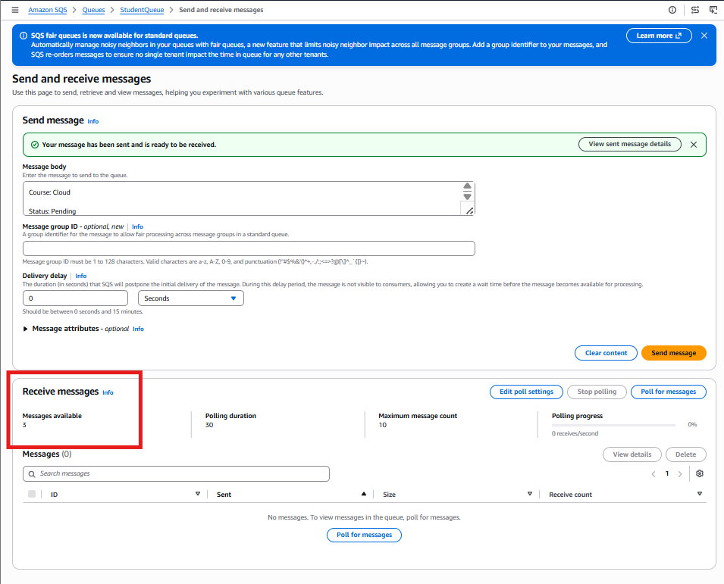

Step 8: Observe
Imagine
Students

↓

Application

↓

Amazon SQS

↓

Backend
The backend has not processed anything yet.
Messages are waiting.
Exactly like customers waiting in a restaurant.

What You Learned
✔ Created Queue
✔ Sent Messages
✔ Queue stores messages
✔ Backend hasn't processed them yet

Lab 2: Receive and Delete Messages
Objective
Learn how applications receive and delete messages.

Architecture
Application

↓

Amazon SQS

↓

Read Message

↓

Delete Message

Step 1
Open
StudentQueue

Step 2
Click
Send and receive messages

Step 3
Under
Receive Messages
Click
Poll for Messages
AWS shows
Message 1

Student Name: Venu
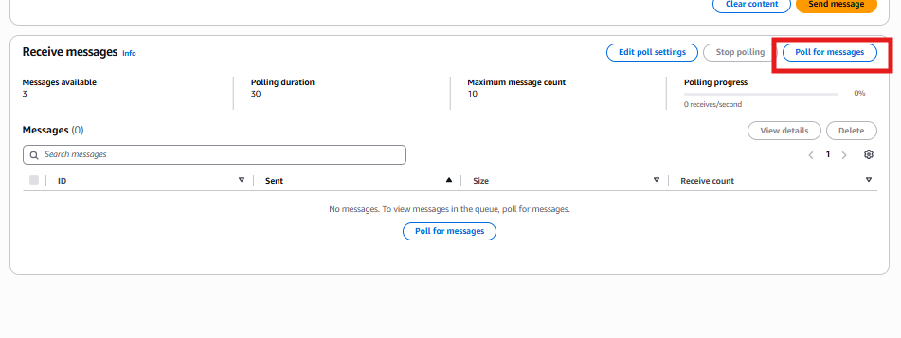
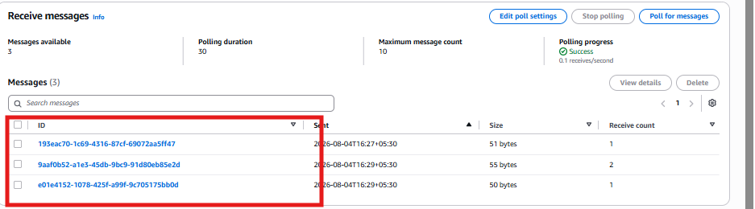

Notice
The message still exists.
Why?
Because reading is NOT deleting.

Step 4
Select the Message.
Click
Delete
Now
Rahul's message disappears.
Repeat for remaining messages.
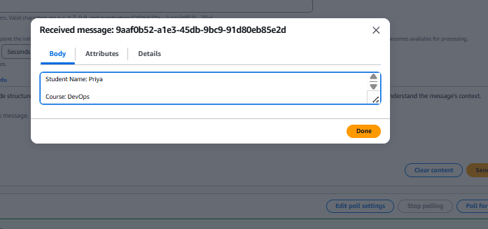

Final Result
Queue becomes
Empty
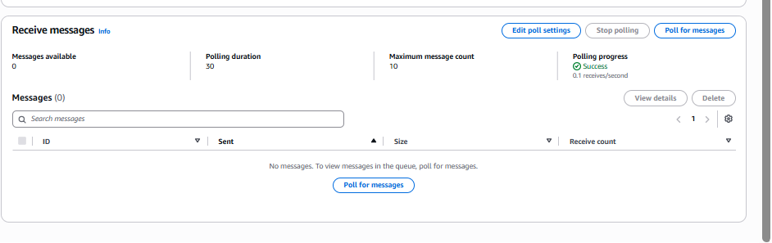

What You Learned
Consumer reads messages.
Consumer deletes messages.
SQS stores messages until deleted or retention expires.

AWS MQ Tasks:
Amazon MQ
Important: Amazon MQ is a paid service and may not be included in the AWS Free Tier in many regions. Creating a broker can incur charges. If you are using a personal AWS account, verify pricing before creating resources.
Lab 1: Create an Amazon MQ Broker
Objective
Create your first managed message broker.

Architecture
Application

↓

Amazon MQ Broker

↓

Application

Step 1
Search
Amazon MQ
Open the service.

Step 2
Click
Create Broker

Step 3
Broker Engine
Choose
ActiveMQ

Step 4
Deployment Mode
Choose
Single-instance Broker
This is sufficient for learning.

Step 5
Broker Name
StudentBroker

Step 6
Username
admin
Password
Create a strong password that meets AWS requirements.
Do not use simple passwords like admin123.
Save the username and password securely because you'll need them later.

Step 7
Leave remaining settings as default.
Click
Create Broker

AWS begins creating the broker.
Provisioning typically takes 15–30 minutes.
Status
Creation in Progress
Eventually
Running

What You Learned
Created
- Broker
- Username
- Password
AWS manages the messaging server.

Lab 2: Explore the Broker
Since connecting a real application requires additional setup and client software, this beginner lab focuses on understanding the broker.

Step 1
Open
StudentBroker
Observe
- Broker ID
- Engine Type
- Deployment Mode
- Status
- Endpoints

Step 2
Think of this flow:
Application A

↓

Amazon MQ

↓

Application B
The broker receives messages and forwards them to the destination application.

What You Learned
- AWS manages the broker.
- Applications communicate through the broker.
- Amazon MQ is ideal for enterprise applications that already use messaging systems.

AWS MQ Tasks:
Amazon MQ
Important: Amazon MQ is a paid service and may not be included in the AWS Free Tier in many regions. Creating a broker can incur charges. If you are using a personal AWS account, verify pricing before creating resources.
Lab 1: Create an Amazon MQ Broker
Objective
Create your first managed message broker.

Architecture
Application

↓

Amazon MQ Broker

↓

Application

Step 1
Search
Amazon MQ
Open the service.

Step 2
Click
Create Broker

Step 3
Broker Engine
Choose
ActiveMQ

Step 4
Deployment Mode
Choose
Single-instance Broker
This is sufficient for learning.

Step 5
Broker Name
StudentBroker

Step 6
Username
admin
Password
Create a strong password that meets AWS requirements.
Do not use simple passwords like admin123.
Save the username and password securely because you'll need them later.

Step 7
Leave remaining settings as default.
Click
Create Broker
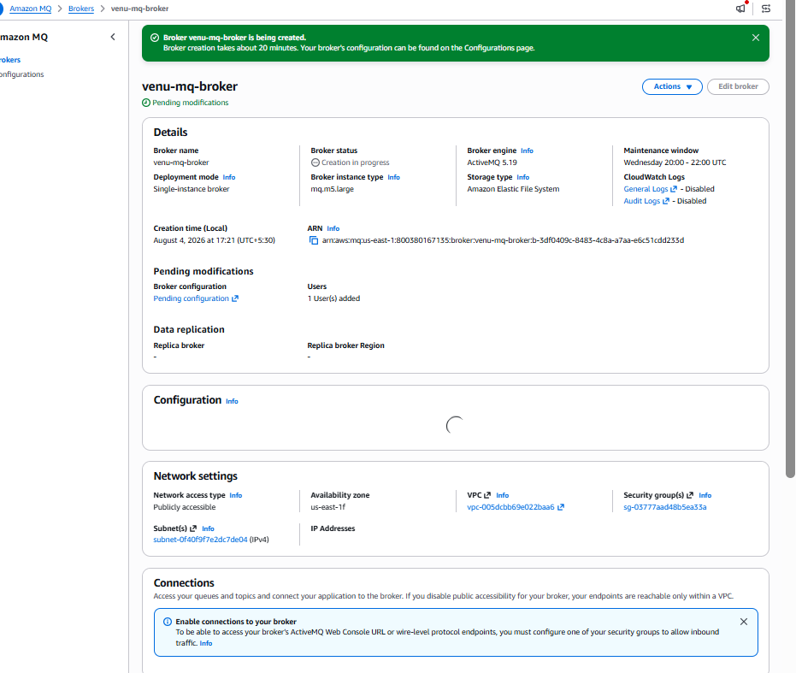

AWS begins creating the broker.
Provisioning typically takes 15–30 minutes.
Status
Creation in Progress
Eventually
Running
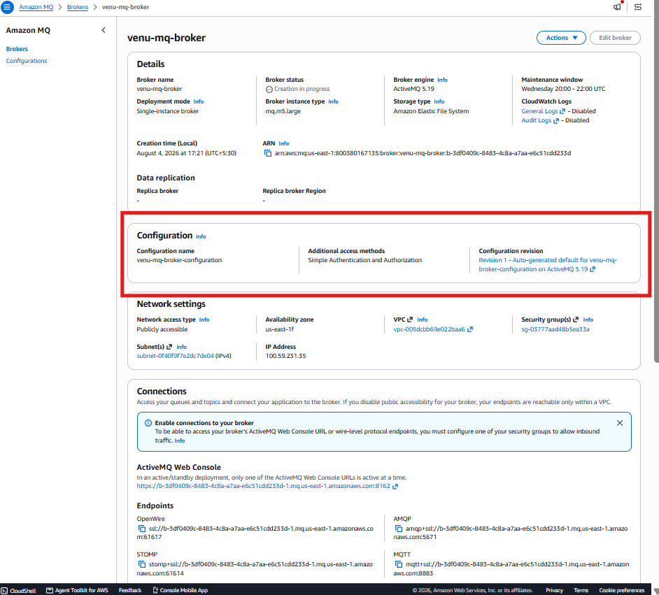

What You Learned
Created
- Broker
- Username
- Password
AWS manages the messaging server.

Task 2: Connect to the ActiveMQ Web Console
Objective
Learn how to:
- Connect to the ActiveMQ Web Console
- Create a queue
- Send a message
- Receive (consume) a message

Step 1: Open Amazon MQ
- Sign in to the AWS Management Console.
- In the search bar, type Amazon MQ.
- Click Amazon MQ.
You should see your broker.
Example:
Broker Name
-----------------------
venu-mq-broker

Step 2: Open the Broker
Click on:
venu-mq-broker
This opens the Broker Details page.

Step 3: Check Broker Status
Verify that the status is:
Running
If it says:
Creation in progress
Wait a few more minutes.

Step 4: Find the ActiveMQ Web Console URL
On the Broker Details page, scroll until you see something like:
ActiveMQ Web Console

https://b-xxxxxxxx-xxxx.mq.ap-south-1.amazonaws.com:8162
Click the URL.
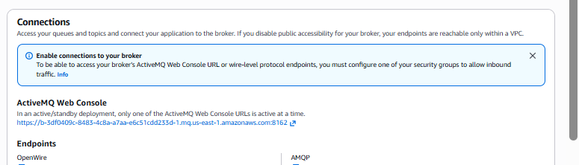
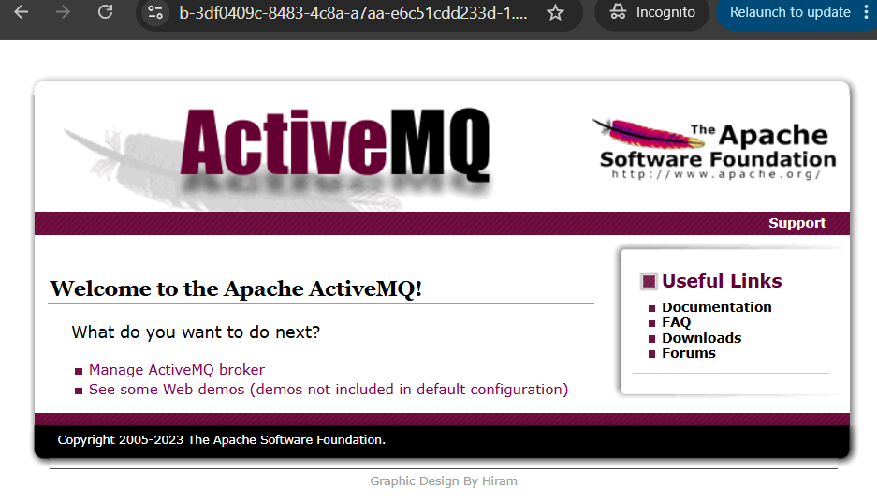

If the URL does not open
Sometimes the browser cannot access the broker because of network or security settings.
If that happens, don't worry. We'll configure the security group or public accessibility if needed.

Step 5: Login
Use the credentials you created while creating the broker.
Example:
Username

admin
Password

Admin@123456
Click
Login
Field | Value
Username | admin(or consoleadmin if admin is unavailable)
Password | Admin@12345678(or another strong password)
Console access | ✅ Enable / Yes

Step 6: ActiveMQ Dashboard
After login, you'll see the ActiveMQ dashboard.
It usually contains menus like:
Home

Queues

Topics

Subscribers

Connections

Network

Scheduled

Send
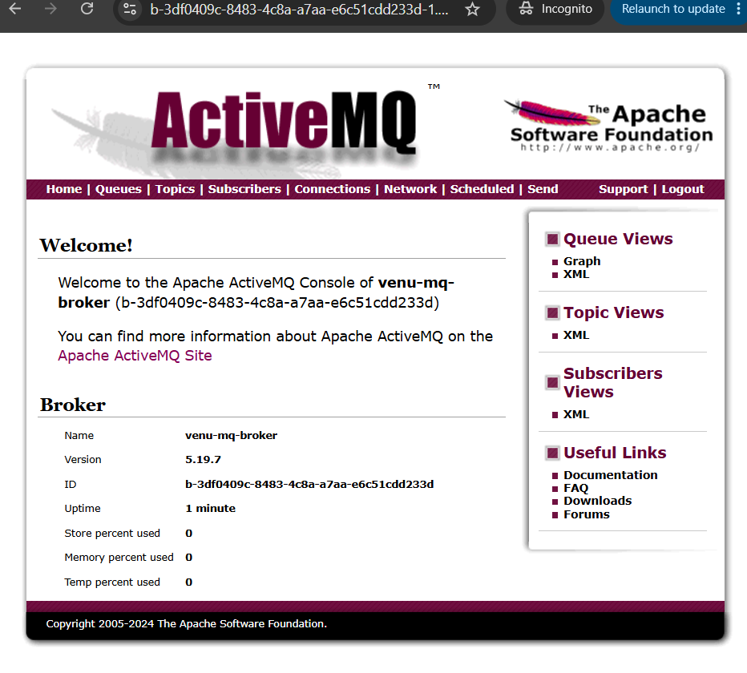

Step 7: Create a Queue
Click:
Queues
Look for:
Create Queue
or
New Queue
Enter:
demo-queue
Click
Create
You should now see:
demo-queue
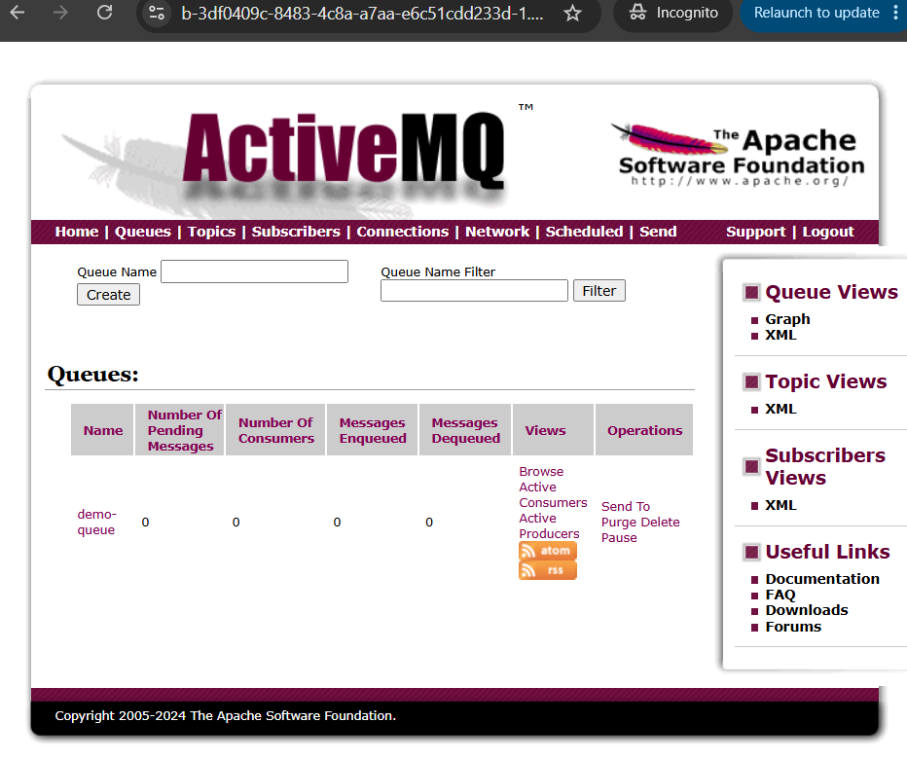

Step 8: Send a Message
Click
Send
Choose
Destination Type

Queue
Destination Name
demo-queue
Message Body
Hello Amazon MQ
Click
Send
You should get a success message.
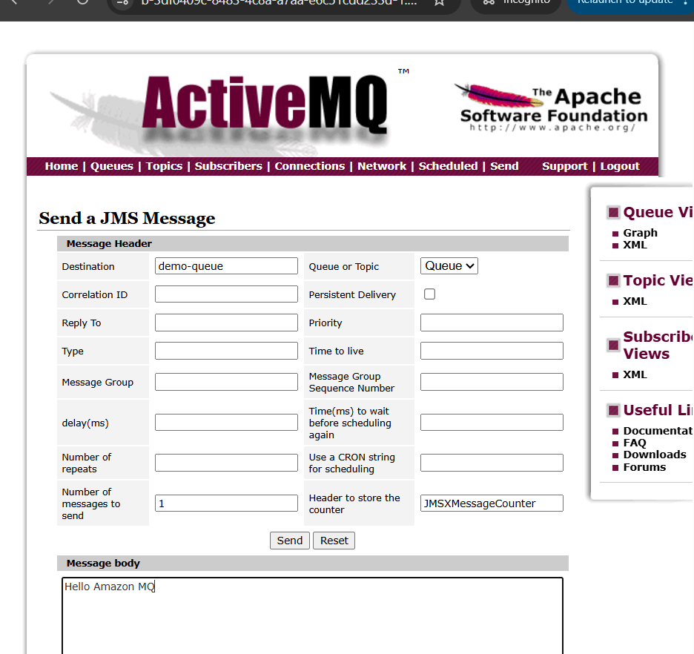

Step 9: Verify Queue
Go back to
Queues
Click
demo-queue
You should see something like:
Queue Name

demo-queue
Pending Messages

1
This means the message is waiting in the queue.
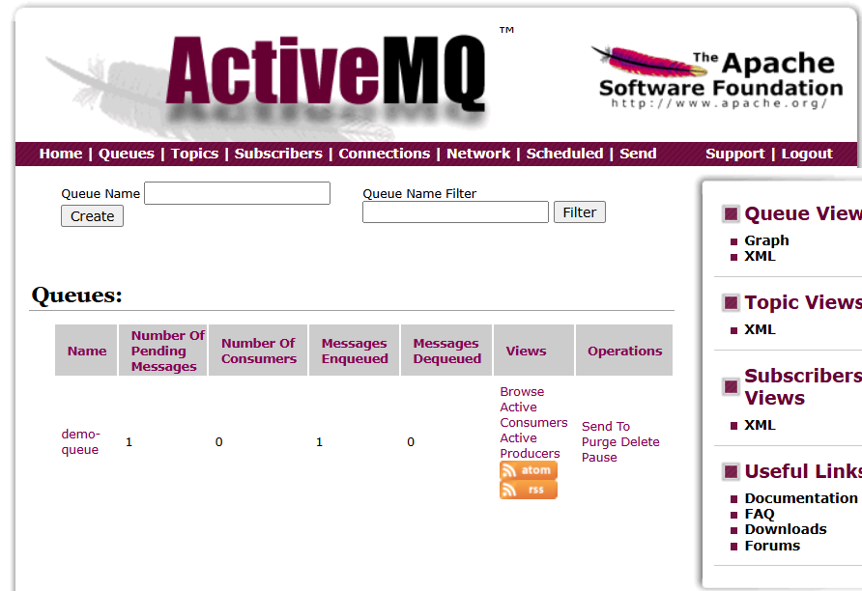

Step 10: Consume the Message
Click
Browse
or
Receive
depending on the ActiveMQ console version.
Open the message.
You should see:
Hello Amazon MQ
After consuming it, the queue should become empty.
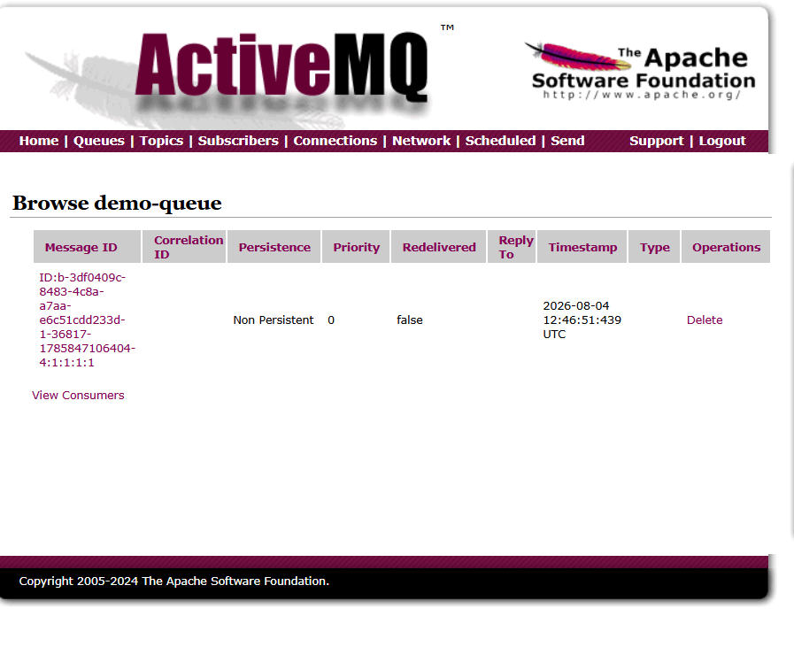
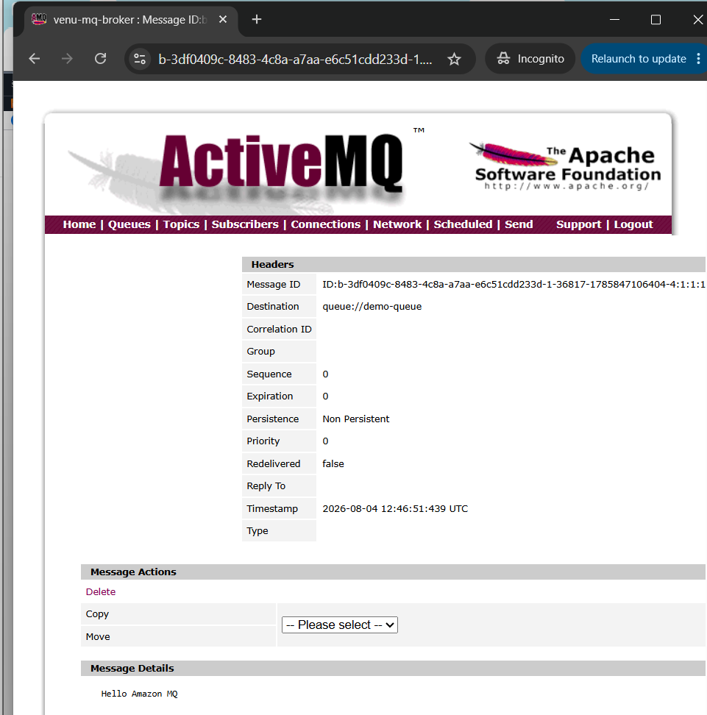

Step 11: Verify
Return to:
Queues
You should now see:
Pending Messages

0
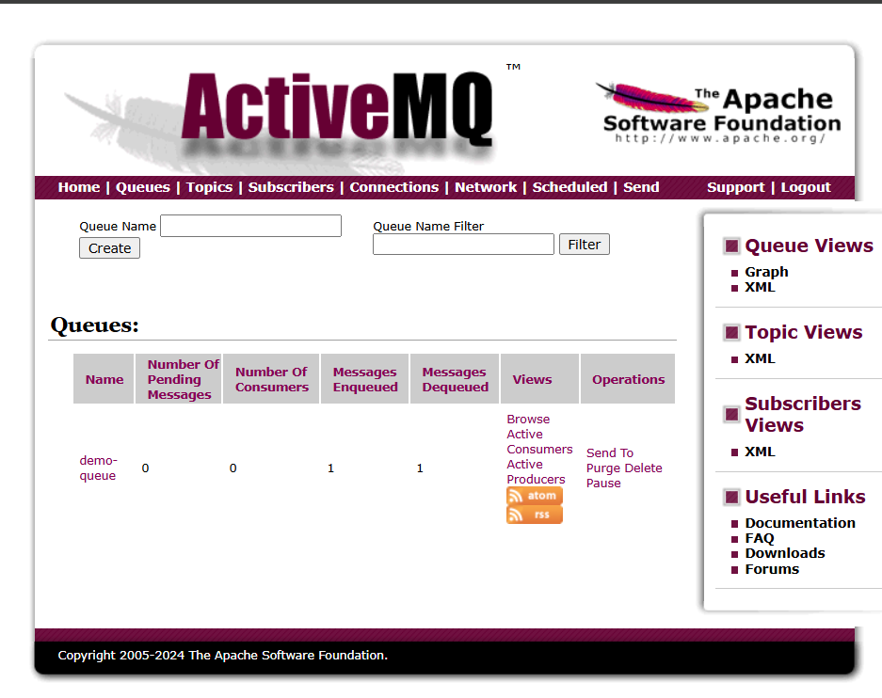
Note:
How do you make it 0?
The ActiveMQ Web Console cannot consume messages like an application does.
To reduce Pending Messages to 0, you need a consumer application (Java, Python, JMS client, etc.) that connects to the broker and receives the message.
For a beginner lab, there are two options:
Option 1 (Recommended for Level 1)
Simply purge the queue.
Click:
Purge
AWS will ask for confirmation.
Click Yes.
Now you'll see:
Pending Messages = 0
Messages Enqueued = 1
Messages Dequeued = 0
The queue is empty because all pending messages were removed.

Option 2 (Advanced - We'll do later)
Create a producer and consumer using code (Java/Python). The consumer will receive the message, and you'll see:
Pending Messages = 0
Messages Dequeued = 1
This demonstrates a real message being consumed rather than deleted.
That means:
- Producer sent a message.
- Broker stored the message.
- Consumer received the message.

Architecture
Producer
│
▼
+-------------+
| Amazon MQ |
| demo-queue |
+-------------+
│
▼
Consumer

Amazon MQ Lab 3 (Level 2)
Objective
Learn how Producer → Broker → Consumer works using an application instead of manually using the Web Console.
Architecture
+-----------+ Send Message +----------------+
| Producer | ---------------------> | Amazon MQ |
| (Python) | | demo-queue |
+-----------+ +----------------+
|
| Receive Message
▼
+----------------+
| Consumer |
| (Python) |
+----------------+

Lab Tasks
Task 1
Install Python (if not already installed).
Check:
python --version

Task 2
Install the required library:
pip install stomp.py

Task 3
Create a Producer.
It will send:
Hello Amazon MQ from Python

Task 4
Create a Consumer.
It will read the message from demo-queue.
After the consumer receives it, you'll see:
Pending Messages = 0
Messages Dequeued = 1
Now you'll understand how real applications use Amazon MQ.
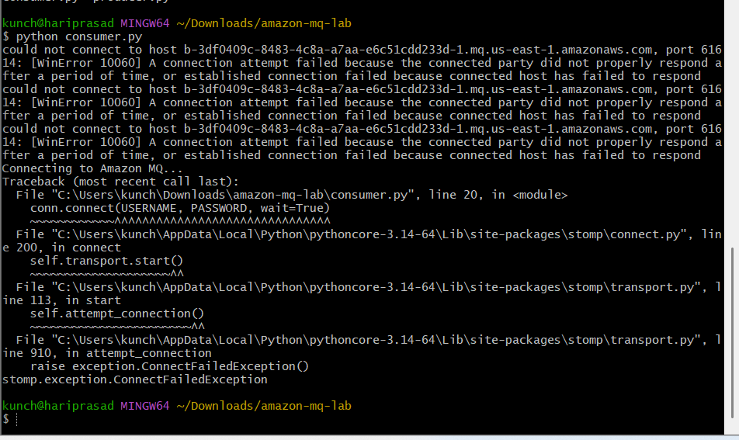

AWS Secrets Manager Task:
Lab 1: Create Your First Secret
🎯 Objective
Create a secret that stores a database username and password.
Imagine you have an application that connects to a MySQL database.
Instead of writing this in your code:
Username = admin
Password = MyPassword123
you store it securely in AWS Secrets Manager.

Step 1: Open AWS Secrets Manager
- Sign in to the AWS Console.
- Change the region to N. Virginia (us-east-1) (or the region where you want to work).
- Search for Secrets Manager.
- Open AWS Secrets Manager.

Step 2: Create a Secret
Click:
Store a new secret

Step 3: Choose Secret Type
Select:
Other type of secret

Step 4: Add Key-Value Pairs
Enter:
Key | Value
username | admin
password | Welcome@123
It should look like:
username : admin
password : Welcome@123
Click Next.

Step 5: Secret Name
Enter:
demo-db-secret
(Optional) Description:
Demo database credentials
Click Next.

Step 6: Configure Rotation
For this beginner lab:
- ❌ Disable automatic rotation
Click Next.

Step 7: Review
Review the details and click:
Store
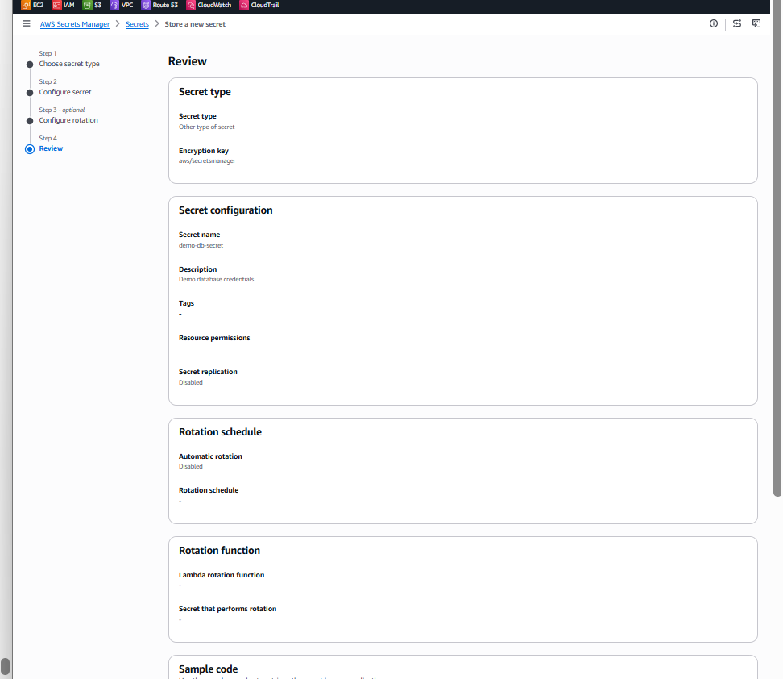
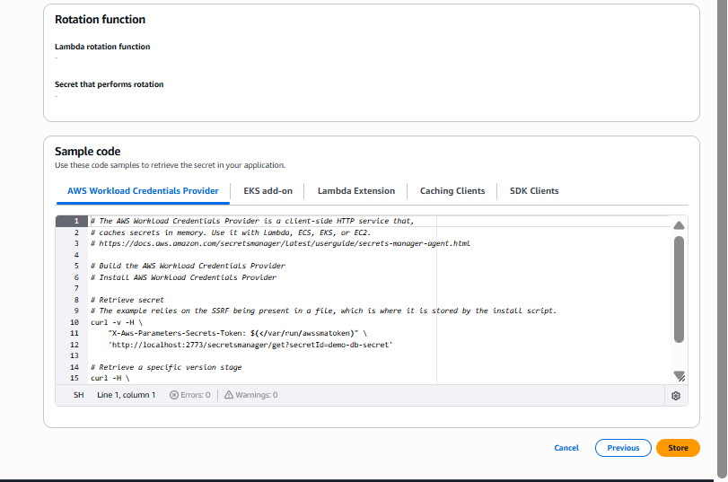

✅ Expected Result
You should now see:
demo-db-secret
When you click it, you'll see information like:
- Secret name: demo-db-secret
- Secret ARN
- Last changed date
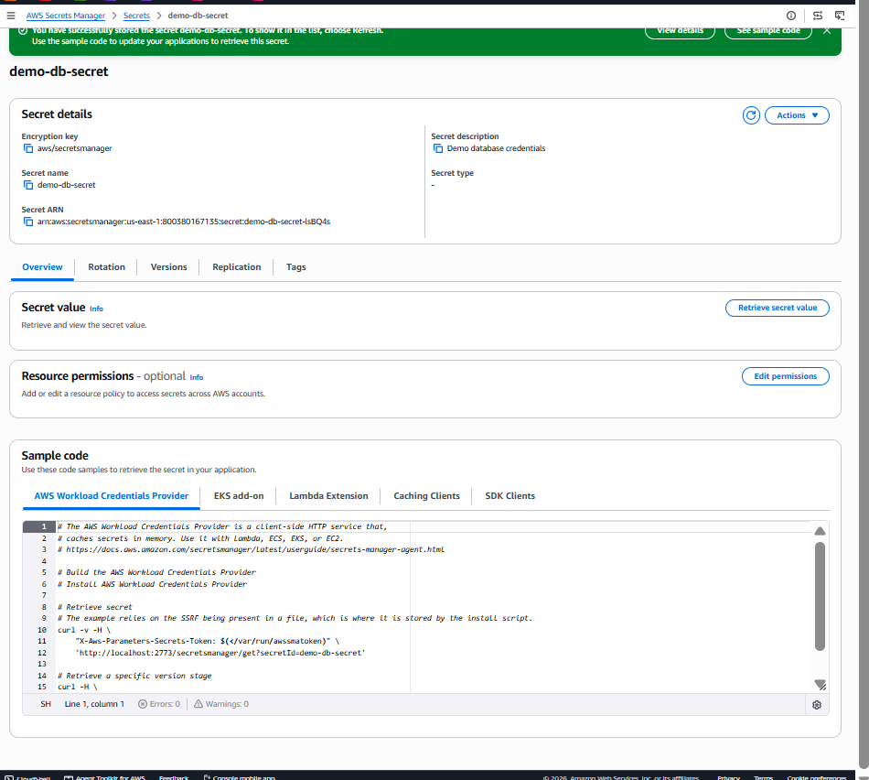

Step 8: View the Secret
Click on demo-db-secret.
Then click:
Retrieve secret value
You should see something similar to:
{
"username": "admin",
"password": "Welcome@123"
}

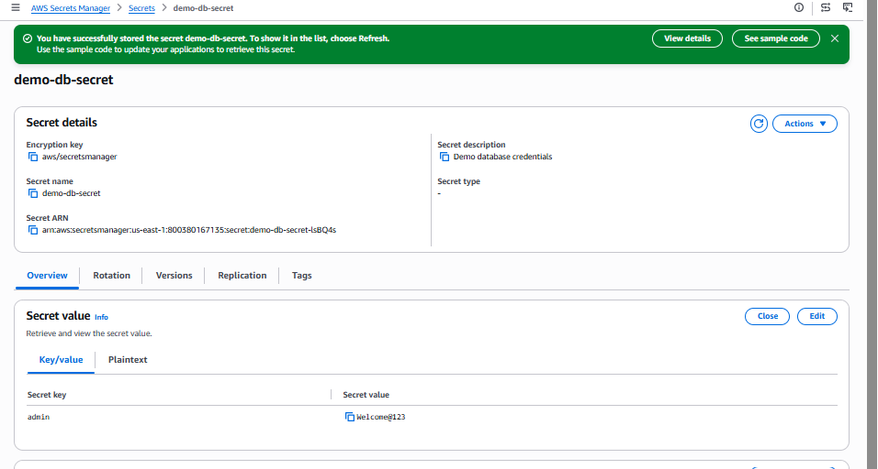

Lab 2: Update (Rotate) a Secret
🎯 Objective
Learn how to update a secret value. This is one of the most common real-world operations.
Imagine your database password changes from:
Welcome@123
to
Welcome@456
Instead of changing it in your application code, you update it in Secrets Manager.

Step 1: Open the Secret
You are already on the demo-db-secret page.
Click:
Edit

Step 2: Update the Secret
Change:
Secret Key | Old Value | New Value
admin | Welcome@123 | Welcome@456
Note: In your screenshot, the key is admin and the value is Welcome@123. Normally, we'd use keys like username and password, but for this lab, just update the existing value.
Click:
Save

Step 3: Retrieve the Secret
Click:
Retrieve secret value
Verify you now see:
admin : Welcome@456
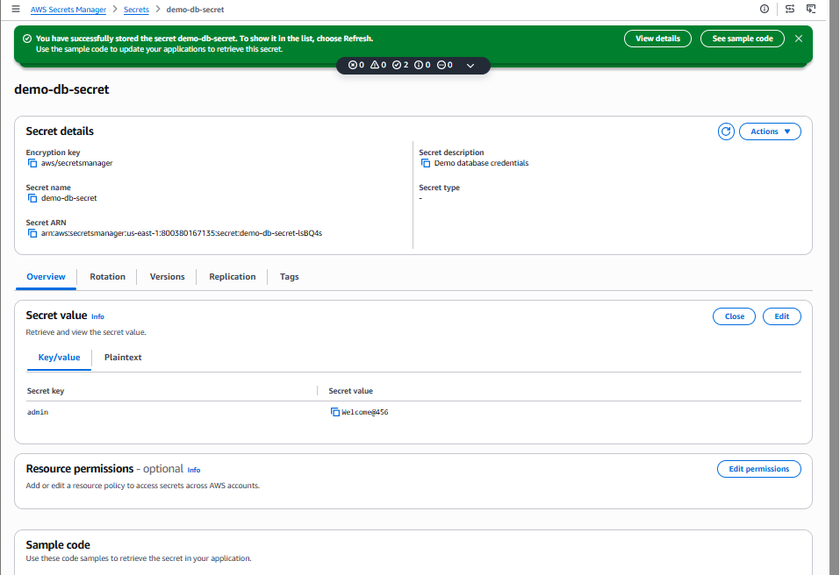

Step 4: Check Versions
Click the Versions tab.
You should see:
Version | Status
Version 1 | Previous
Version 2 | Current
This shows Secrets Manager keeps version history.
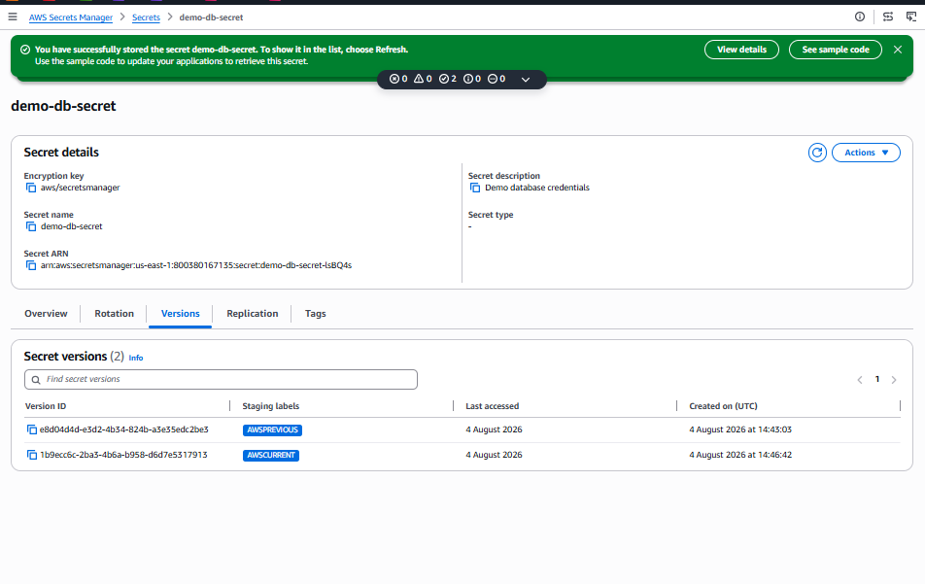

✅ Lab Completed
You have now learned how to:
- ✅ Create a secret
- ✅ Store sensitive information
- ✅ Update a secret
- ✅ View secret versions

💼 Real-World Example
Suppose your application connects to an Amazon RDS MySQL database.
Without Secrets Manager
Application
│
▼
Password written inside the code ❌
If the password changes, you must modify the code and redeploy.

With Secrets Manager
Application
│
▼
AWS Secrets Manager
│
▼
Database Password
The application reads the password securely at runtime.

